**SOS4Love Project**

**MISSION AGAPE REPORT**

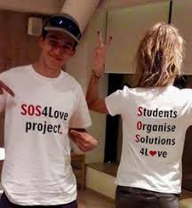

**Please complete & email to** [**info@sos4loveproject.com**](mailto:info@sos4loveproject.com) **, under the Title: REPORT Mission AGAPE**

**Your report will be uploaded on the SOS4love Project Site under Calendar & missions button.**

1. **School/Organisation/Country: ………SMA Negeri 1 PURWOSARI………………………………………………………………………………………………………………………………………………………………………………………………………………………………………………………………..**
2. **Teacher or Youth Participant Name & Last Name - Subject taught in class if Mission AGAPE action takes place in school/university context:**

**Mrs. Diana Herawati_ English ………………………………………………………………………..……………………………………………………………………………………………………………………………………………………………………………………………………………….**

__________________________________________________________________________________________________________________________________________________________________

________________________________________________________________________________________________________________________________________________________________________________________________________________________________________________________________________________________________________________________________________________________________________________________________

**3) Describe your Mission AGAPE Action in brief and its results.**  ._Love is not always about having. But love is about sincerity. Thank you for all the flavors. Remain sincere even though we don't get love from the people we love. Life becomes more meaningful _________________________________________________________________________________________________________________________________________________________________________________________________________________________________________________________________________________________________________________________________________________________________________________________________________________________________________________________________________________________________________________________________________________________________________________________________________________________________________________________________

**4) Share your feelings and reflections on your experience throughout MISSION AGAPE as well your impression on the innovative Space Tool-Kit: ‘ACT like a Cosmo-Astronaut for a New Earth of Peace’ and the ‘SOS4love Goes to Space for SDGs’ App. My feelings have become calmer and more meaningful** __________________________________________________________________________________________________________________________________________________________________________________________________________________________________________________________________________________________________________________________________________________________________________________________________________________

----------------------------------------------------------------------------------------------------------------------------------------------------------------------------------------------------------------------------------------------------------------------------------------------------------------------------------------------------------------------------------------------------------------------------**5) Which of the following special skills and ethos of the Cosmo-Astronauts you believe students/youth had a chance to cultivate throughout your MISSION-AGAPE Action? Highlight the ones that apply to you:** Adaptability, resilience, physical condition, mental endurance, leadership, scientific scrutiny, communication skills, out of the box thinking, synthetic and analytical thinking, imagination, creativity, ethos of respect, problem solving, work under pressure, ability to make detailed observations, proactiveness, multi-tasking, ability to focus on following procedures, robotics, repair skills, teamwork, ethos of working for the benefit of all, ability to see the BIG Picture.

Thank you for Acting 4Love World-Changers! Looking forward to seeing you next year in the SOS4Love Project again, to Keep Changing the World Together with #Pedagogy4Love!

BECAUSE TRUE LOVE IS EVER LASTING!

 

**THANK YOU for your commitment to the SOS4Love Project**

**MAKING a new future of PEACE and AGAPE on Earth Possible**

**with the Power of your HEART, #Pedagogy4love, #Space4SDGs, #SOS4loveUkraine**

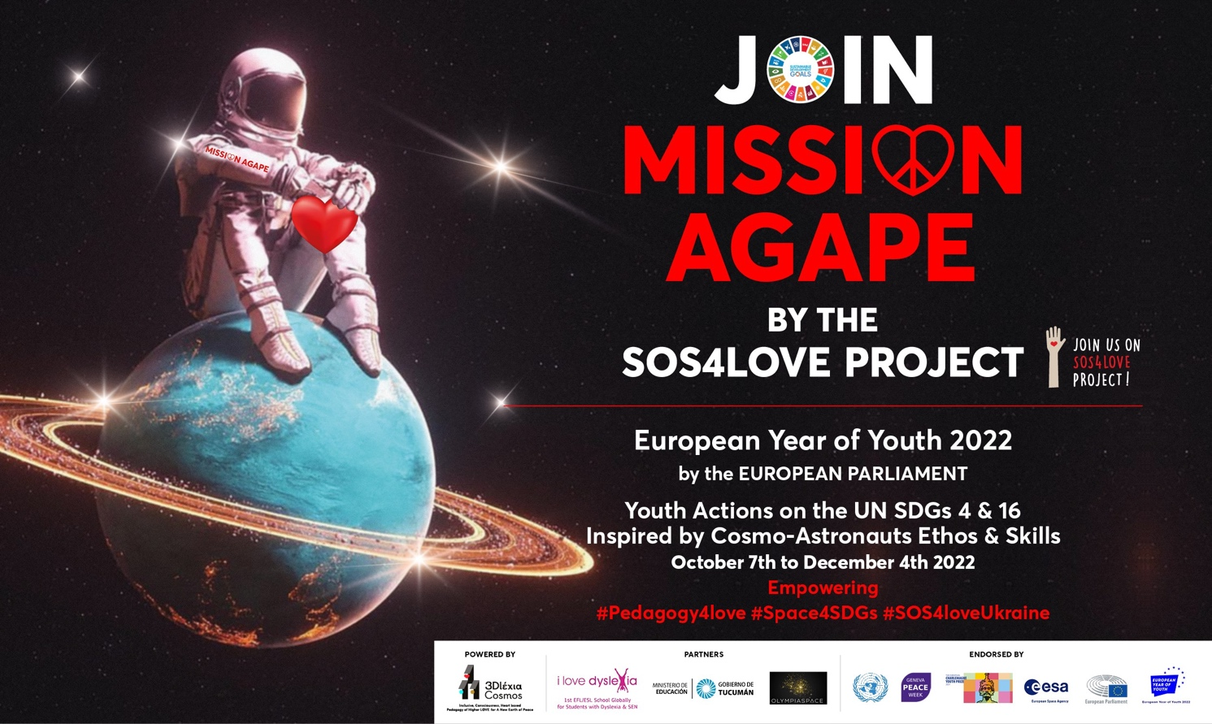

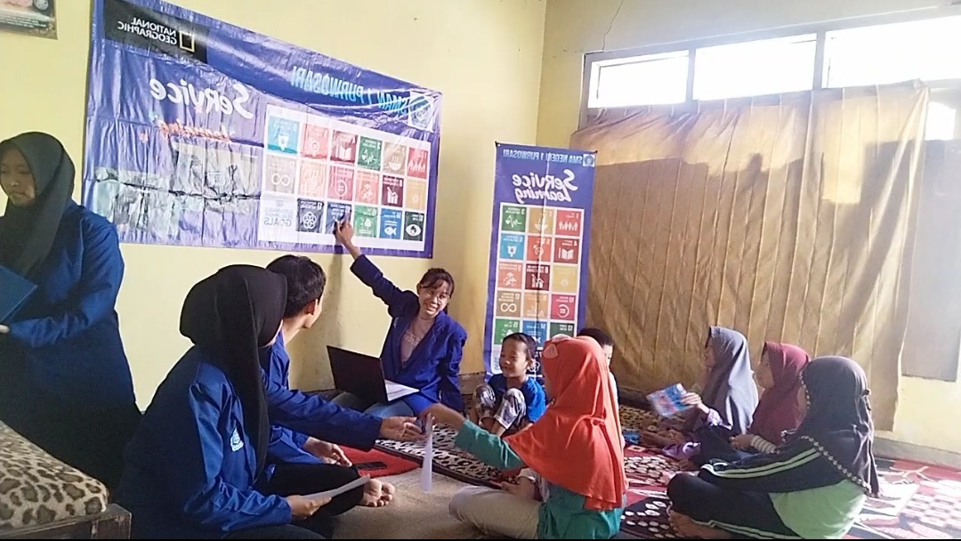

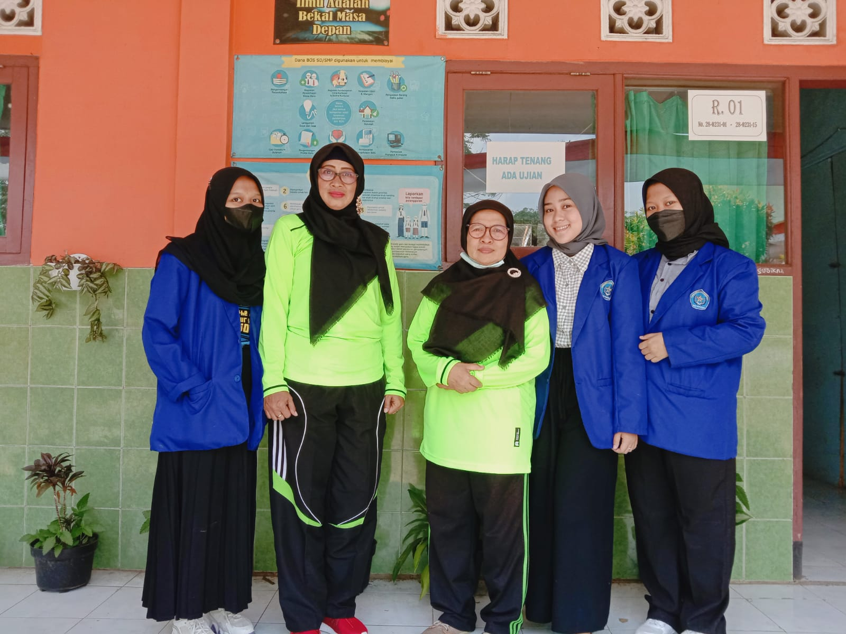

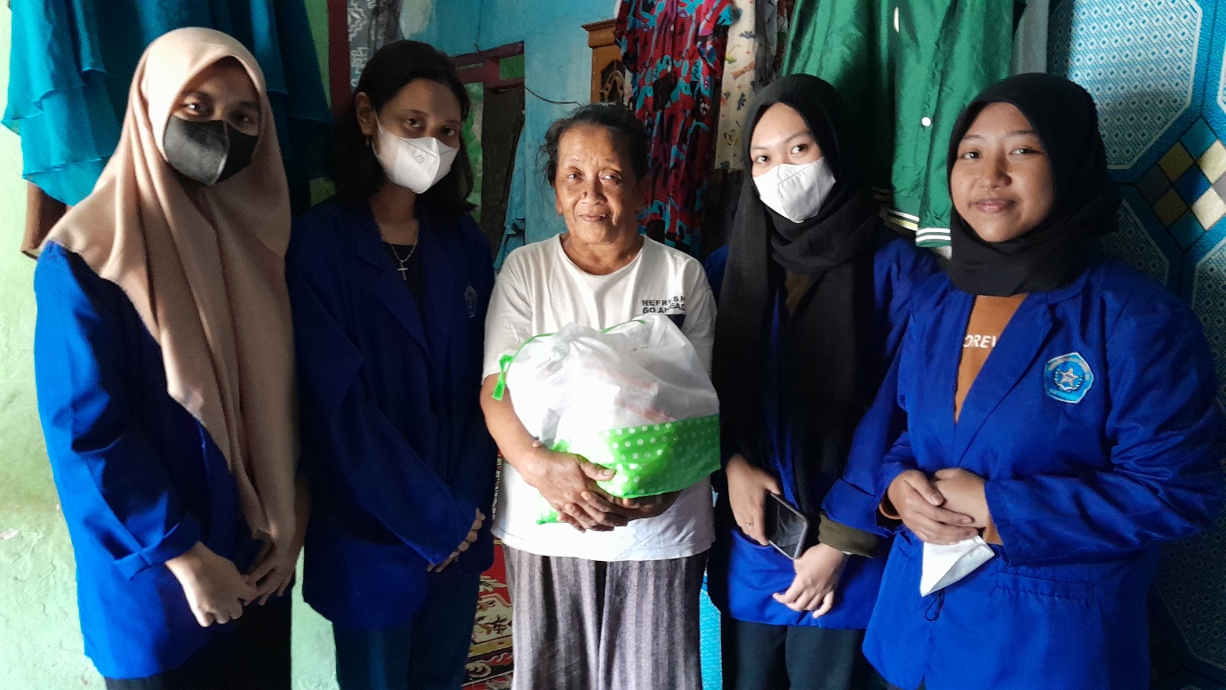

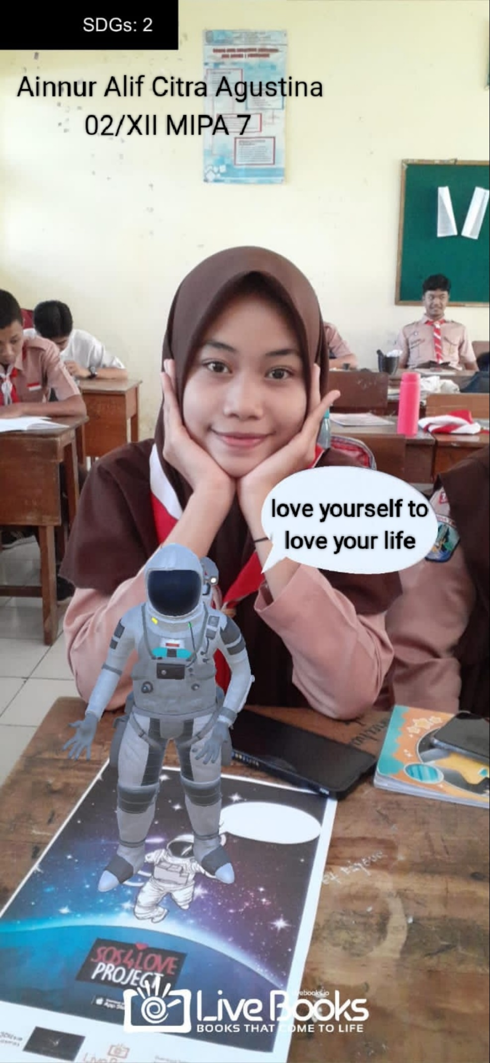

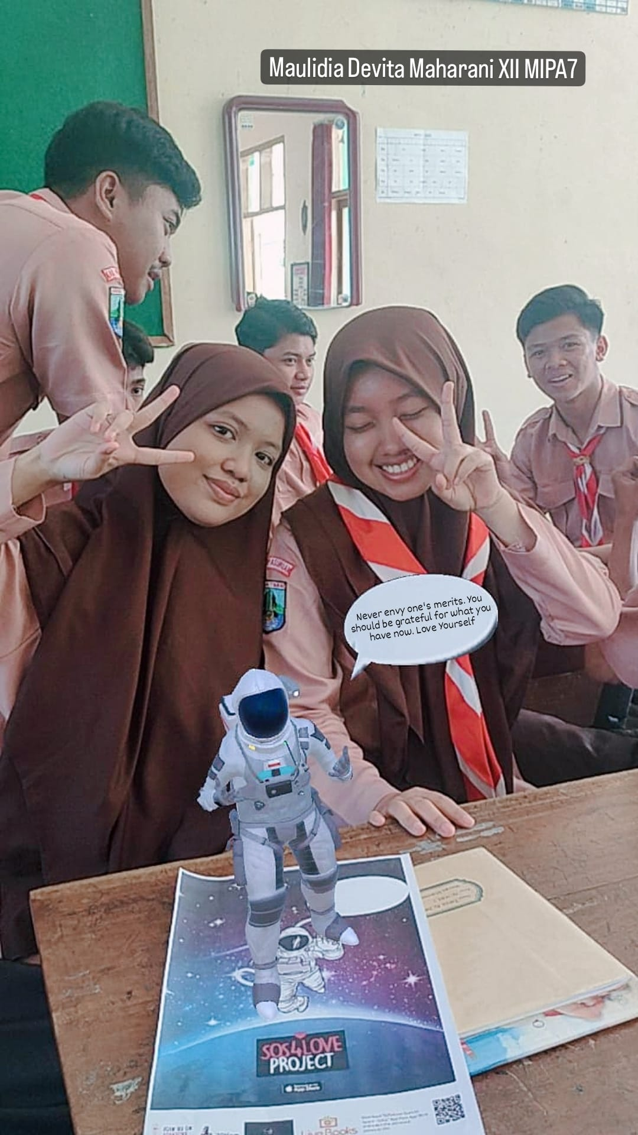

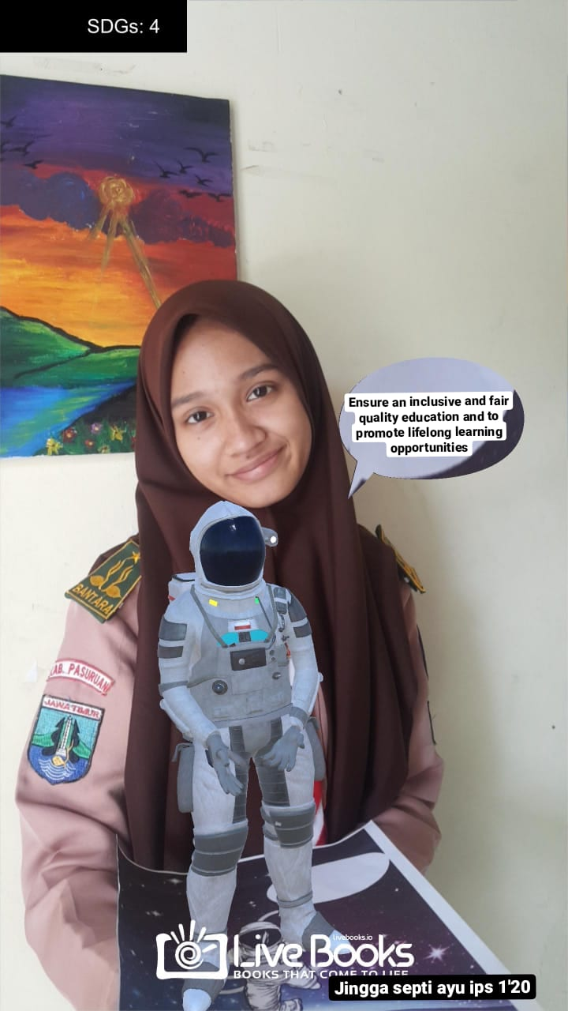

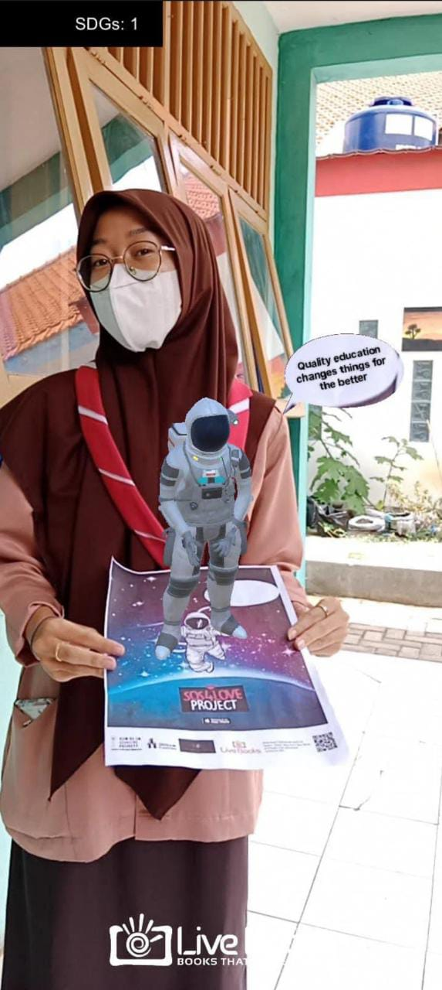

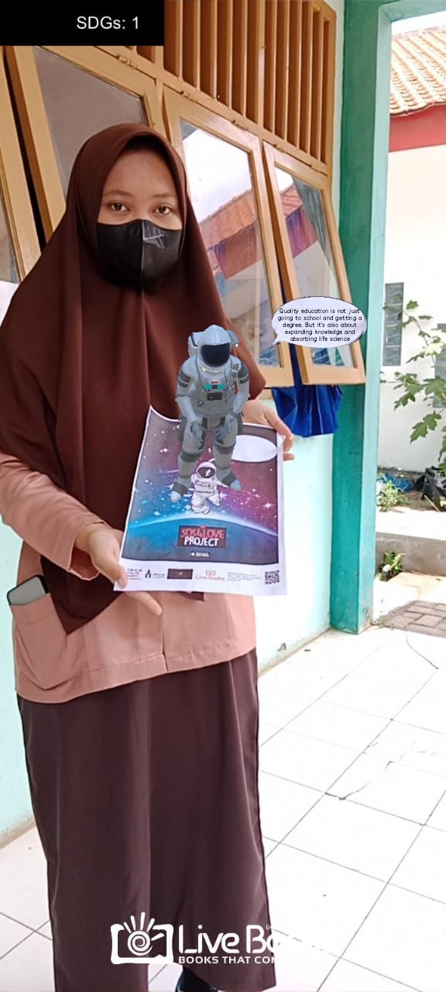

**Yogi Wibowo**

Her mission is to face problems and fear with love. As we know, human beings will not escape the problem. Fear arises when a person is facing a problem. When you are afraid to communicate with friends. Fear of the response given and you're worried that your listeners won't understand what you're talking about. But with the power of love, communication can be established so that it can alleviate a problem. It can even solve it well.

**4) Share your feelings and reflections on your experience throughout MISSION AGAPE as well your impression on the innovative Space Tool-Kit: ‘ACT like a Cosmo-Astronaut for a New Earth of Peace’ and the ‘SOS4love Goes to Space for SDGs’ App.**

My feelings after the mission were happy and relieved because I could express my feelings. As well as being able to take on new challenges that are still unfamiliar to me. It can strengthen my mentality and courage. Like the first time I tried the '5054love Goes to Space for SDGs' app. It's great to get to know new technology. From this project, I can broaden my way of thinking. Of course it's great fun. Turns out to join the mission, so easy.__________________________________

**5) Which of the following special skills and ethos of the Cosmo-Astronauts you believe students/youth had a chance to cultivate throughout your MISSION-AGAPE Action? Highlight the ones that apply to you:** Adaptability, resilience, physical condition, mental endurance, leadership, scientific scrutiny, communication skills, out of the box thinking, synthetic and analytical thinking, imagination, creativity, ethos of respect, problem solving, work under pressure, ability to make detailed observations, proactiveness, multi-tasking, ability to focus on following procedures, robotics, repair skills, teamwork, ethos of working for the benefit of all, ability to see the BIG Picture.

