Nombre de la Institución: Escuela Secundaria Tafi Viejo

Docente a cargo: Paola Elizabeth Ochoa

Curso: 6to año B

First Week

Hello!!! My name is Paola Elizabeth Ochoa. I’m a happy English Teacher. Let me tell you about me. I’m 42 years old. I’m married with Javier who is actually an English teacher too. We do not have children of our own so my students are my beloved siblings.

At the moment I’m teaching English in a school called “Escuela Secundaria Tafi Viejo”. It is situated in Tafi Viejo city in the Tucuman Province.

My beautiful class is formed by 10 students from the 6th year. They are very collaborative and they like to participate in every adventure I come up with in order to learn.

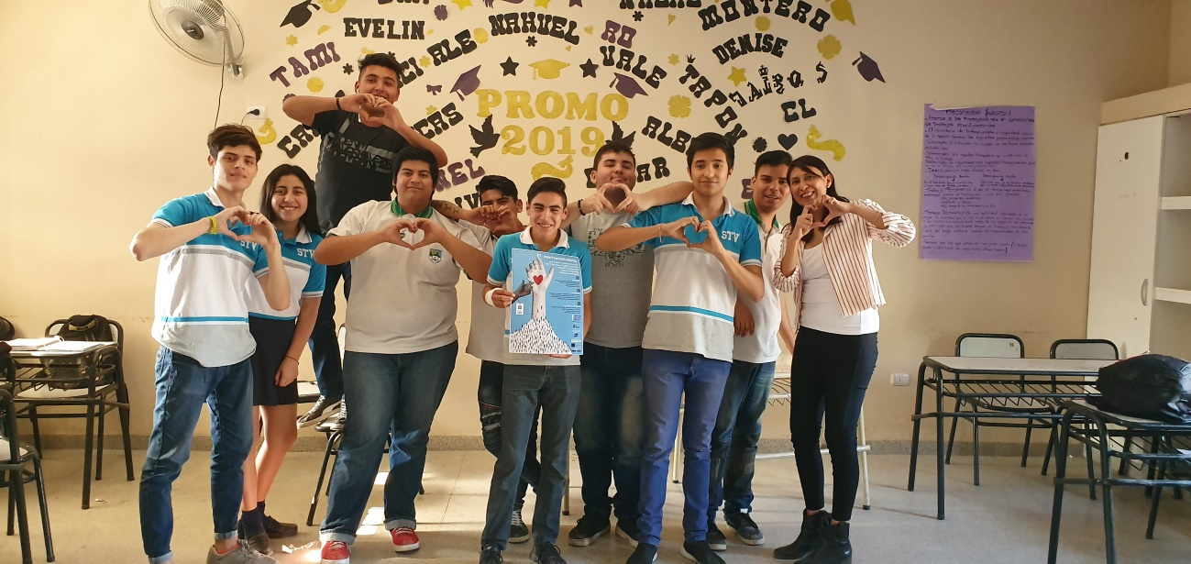

We worked in class with the United Nations Sustainable Development Goals where they download the barcode from the poster, and they looked at the SOsS4Love page and they gave a glance to the 17 Global issues. They got aware of our world’s situation and about the need to act inmediately.

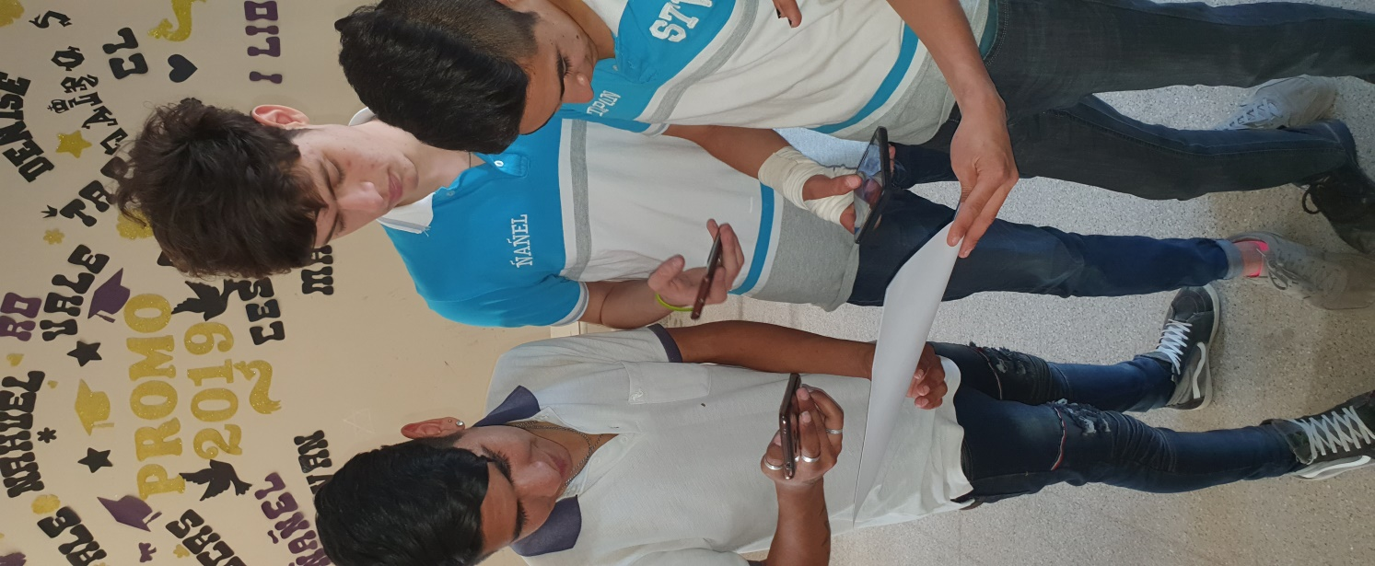 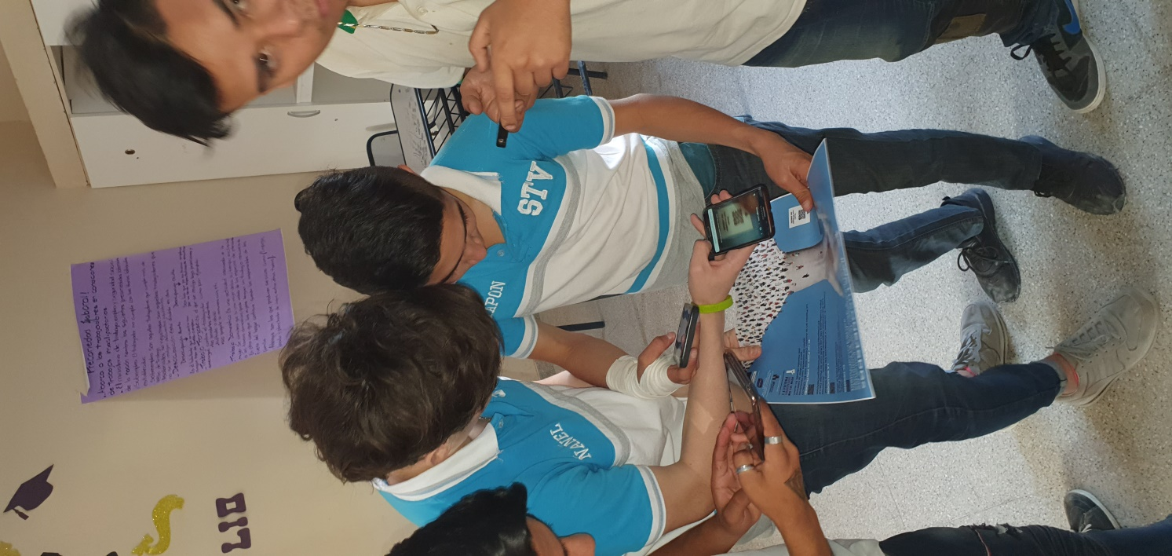

So, We are prepared to make our world a better place for us and for aur children.

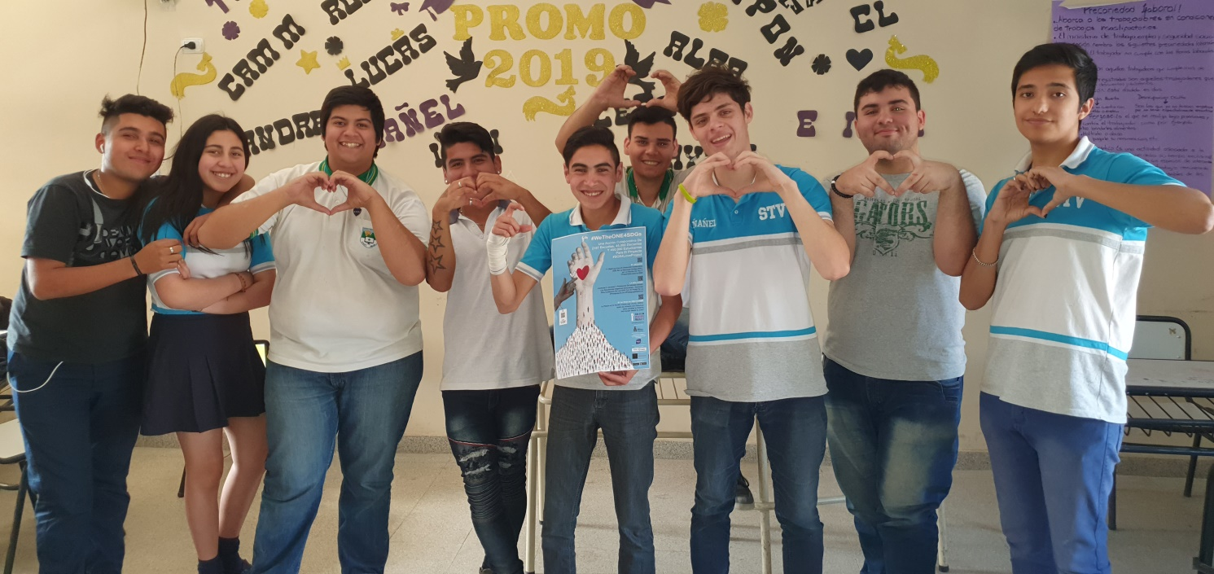

Our team is formed by:

* **Nahuel**
* **Enzo**
* **Evelin**
* **Rocio**
* **Hector**
* **Ivan**
* **Manuel**
* **Matias**
* **Gaston**
* **Emiliano**

**Thank you.**