**WEEK 1 SOS4LoveProject3**

**Goal 12 Responsible consumption and production**

**Project theme: “Sort garbage, get clean environment”**

**04/10-13/10**

**Secondary school №11 of Romny, Sumy region, Ukraine**

**8-А form**

**Chemistry Teacher:** Alla Kvashko

**Personal qualities:** responsible, active, creative

**Hobbies:** travelling

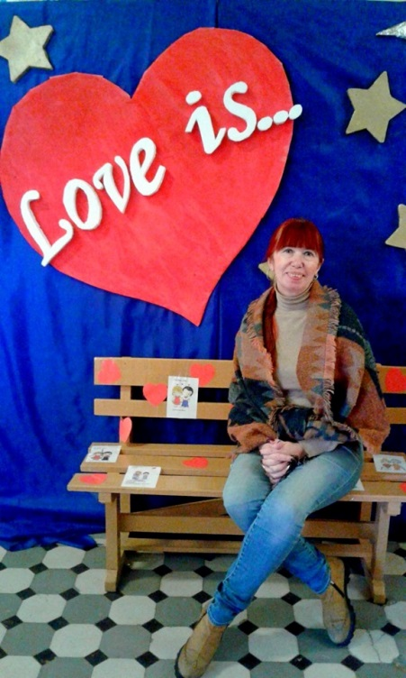

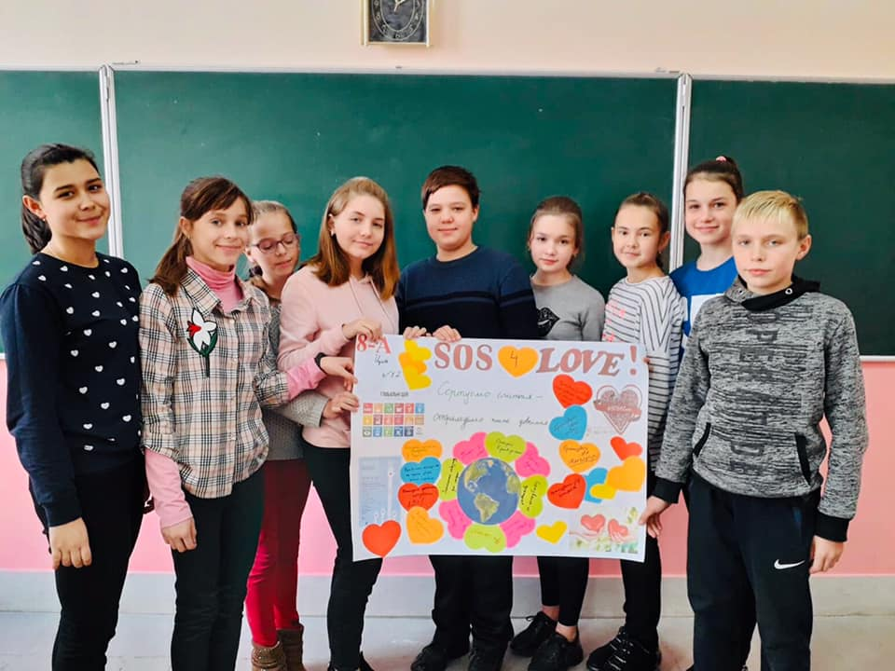

**WEEK 1 SOS4LoveProject3**

**Goal 6 Clean water and sanitation**

**Project theme: “No water - no life”**

**04/10-13/10**

**Secondary school №11 of Romny, Sumy region, Ukraine**

**10 form**

**The Ukrainian language and literature teacher:** Natalia Shkurska

**Personal qualities:** creative, imaginative, easy-going

**Hobbies:** embroidering, reading

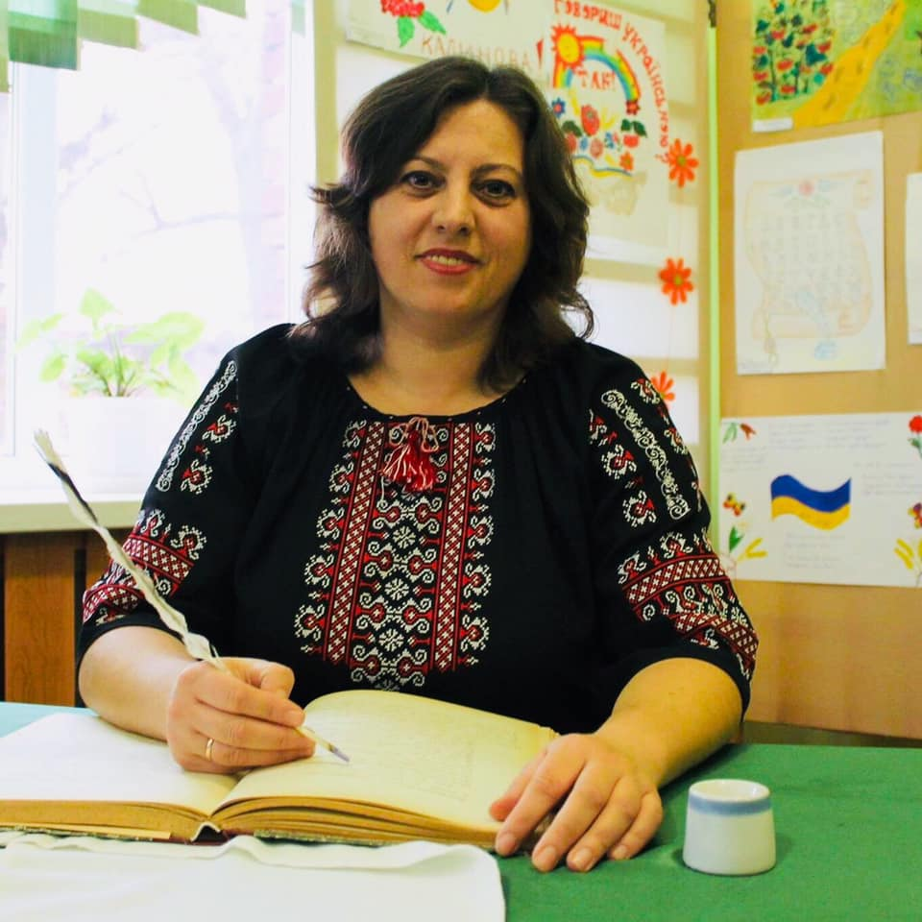

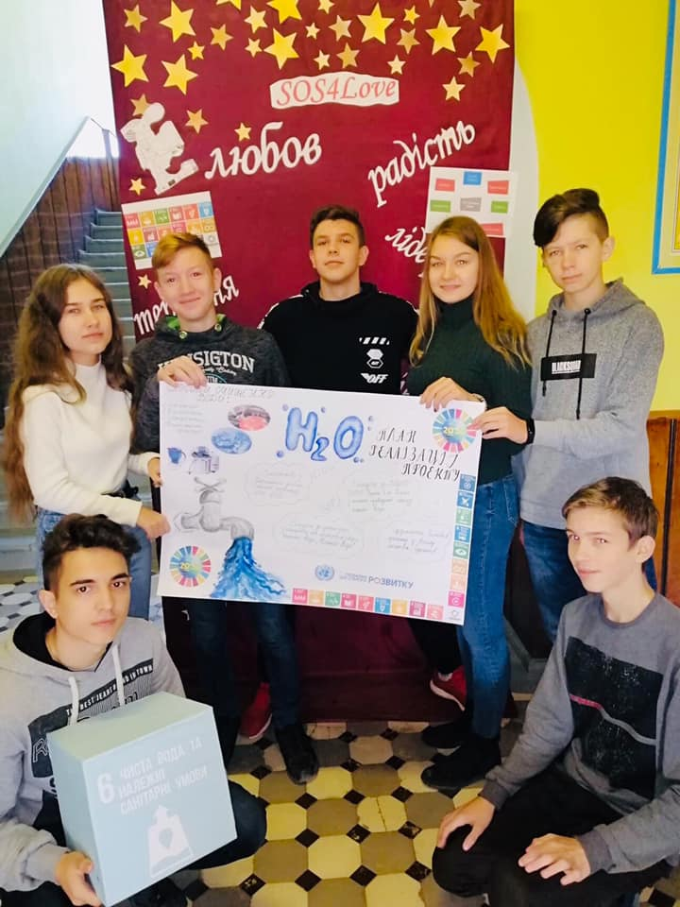

**WEEK 1 SOS4LoveProject3**

**Goal 6 Clean water and sanitation**

**Project theme: “Clean water is the source of a healthy life”**

**04/10-13/10**

**Secondary school №11 of Romny, Sumy region, Ukraine**

**9 B form**

**Health Basics Teacher:** Tetiana Donets

**Personal qualities:** hard-working, active, self-confident

**Hobbies:** travelling, reading, pet lover

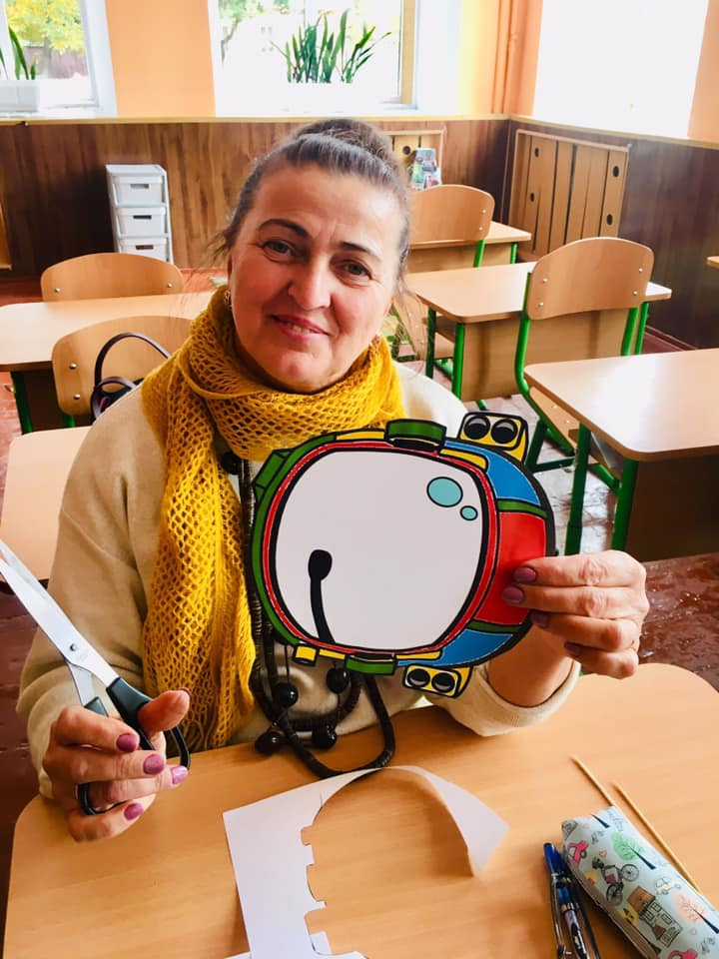

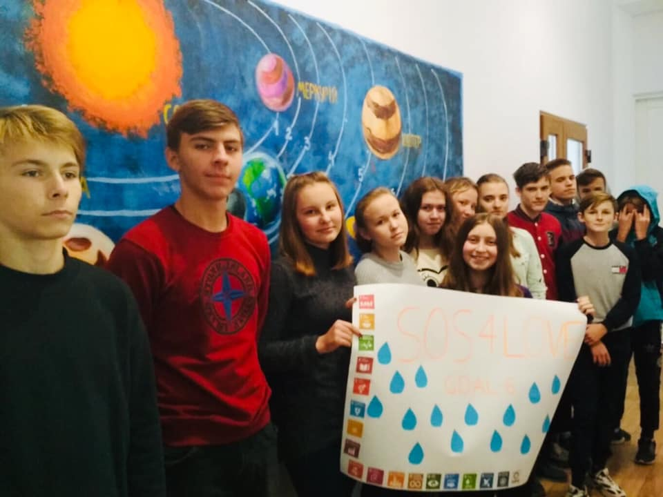

**WEEK 1 SOS4LoveProject3**

**Goal 8 Decent work and economic growth**

**Project theme: “Future profession is the key to success”**

**04/10-13/10**

**Secondary school №11 of Romny, Sumy region, Ukraine**

**8 B form**

**Biology Teacher:** Olga Shevchenko

**Personal qualities:** amusing, active, honest

**Hobbies:** reading, watching old movies

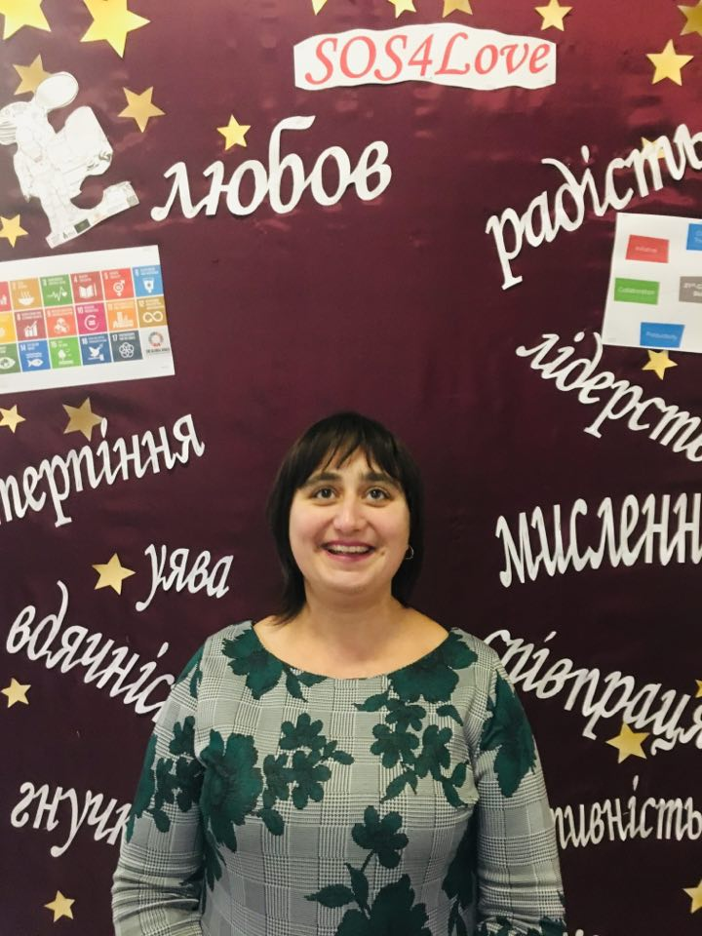

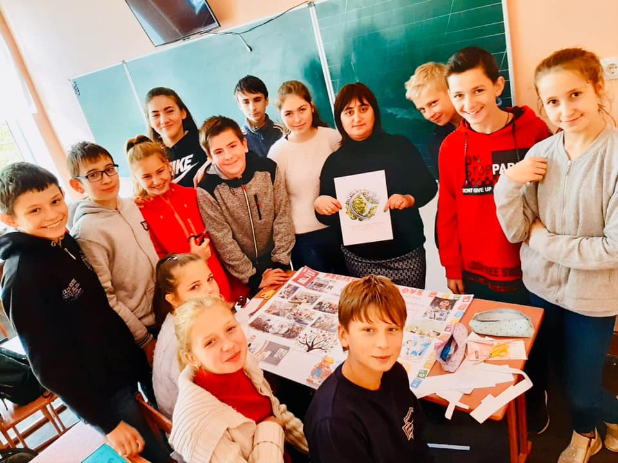

**WEEK 1 SOS4LoveProject3**

**Goal 6 Good health and well-being**

**Project** **Theme “Vaccination problems”**

**04/10-13/10**

**Secondary school №11 of Romny, Sumy region, Ukraine**

**6 A form**

**IT Teacher:** Olena Shevchenko

**Personal qualities:** honest, polite, caring

**Hobbies:** sport, programming, web design

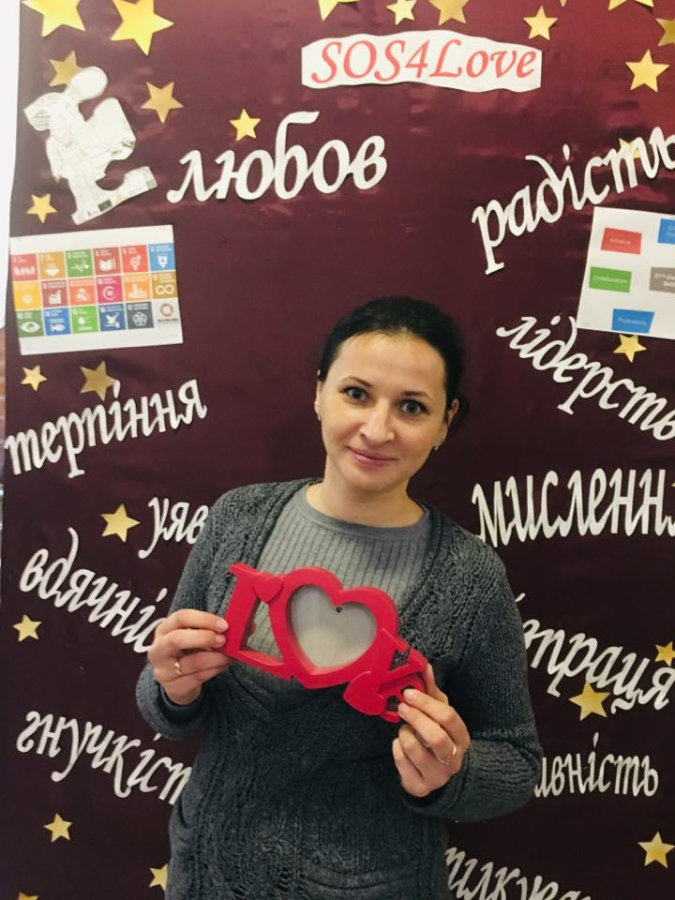

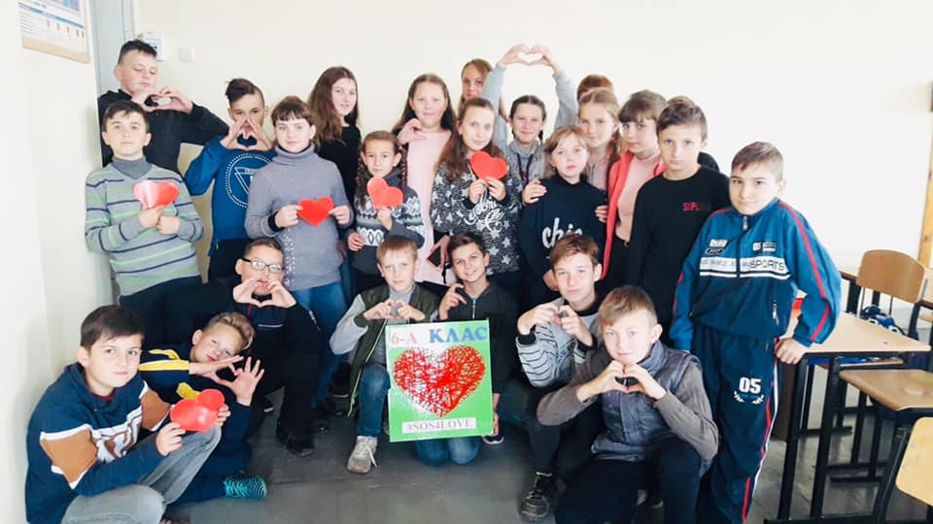

**WEEK 1 SOS4LoveProject3**

**Goal 11 Sustainable cities and communities**

**Project Theme “A travelling guidance”**

**04/10-13/10**

**Secondary school №11 of Romny, Sumy region, Ukraine**

**5 A, 5B forms**

**English Teachers:** Tetiana Krepochina, Oksana Tkachova

**Tetiana’s personal qualities:** serious, reserved, responsible

**Oksana’s personal qualities:** fair, reliable, helpful, good sense of humour

**Tetiana’s hobby:** reading English books

**Oksana’s hobby:** travelling, gardening, self-development

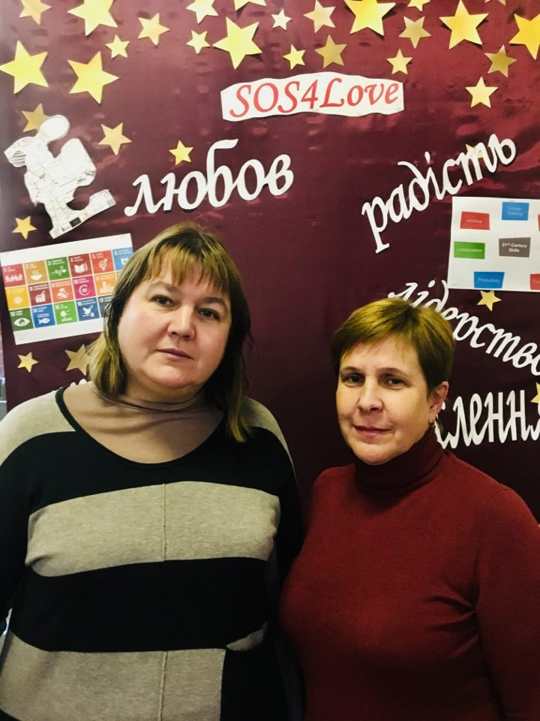

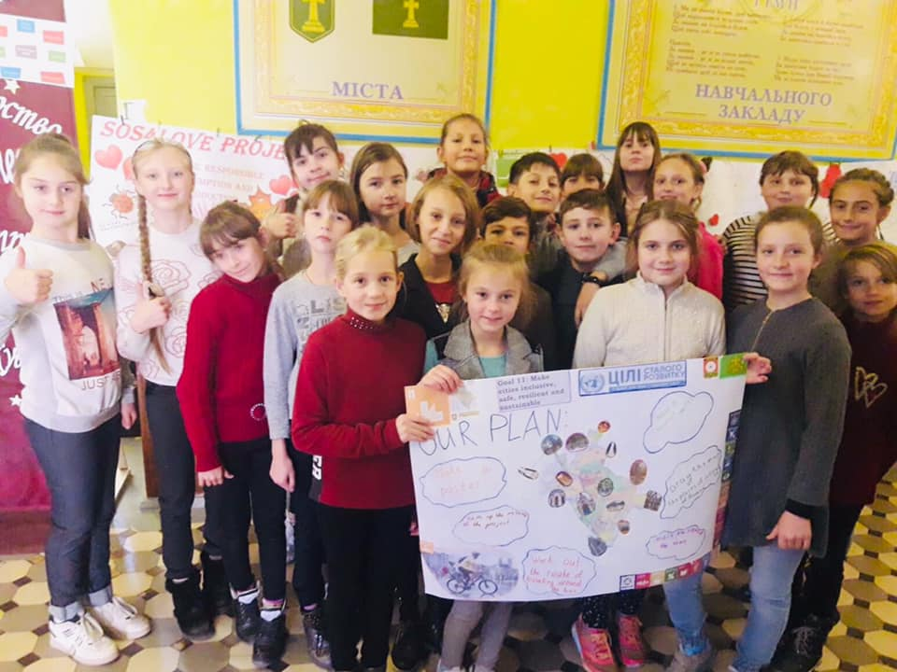

**WEEK 1 SOS4LoveProject3**

**Goal 15 Life on Land**

**Project Theme “Love the Earth, save the world!”**

**Agitation team of the student forestry “Soveniatko”**

**04/10-13/10**

**Secondary school №11 of Romny, Sumy region, Ukraine**

**The vice principal, IT Teacher:** Liudmyla Bakai

**Personal qualities:** reliable, sociable, creative

**Hobbies:** English, web design, reading, travelling



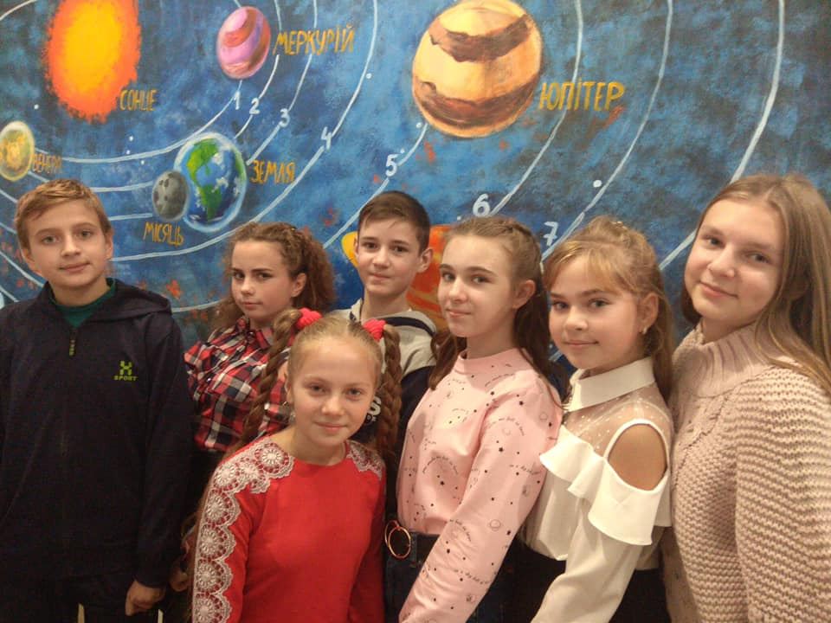

**WEEK 1 SOS4LoveProject3**

**Goal 5 Gender equality**

**Project Theme “Girls can do everything!”**

**STEM Girls**

**04/10-13/10**

**Secondary school №11 of Romny, Sumy region, Ukraine**

**The school principal, Geography Teacher:** Viktoria Zelenska

**Personal qualities:** sociable, trustworthy, outgoing

**Hobbies:** travelling, gardening, photographing



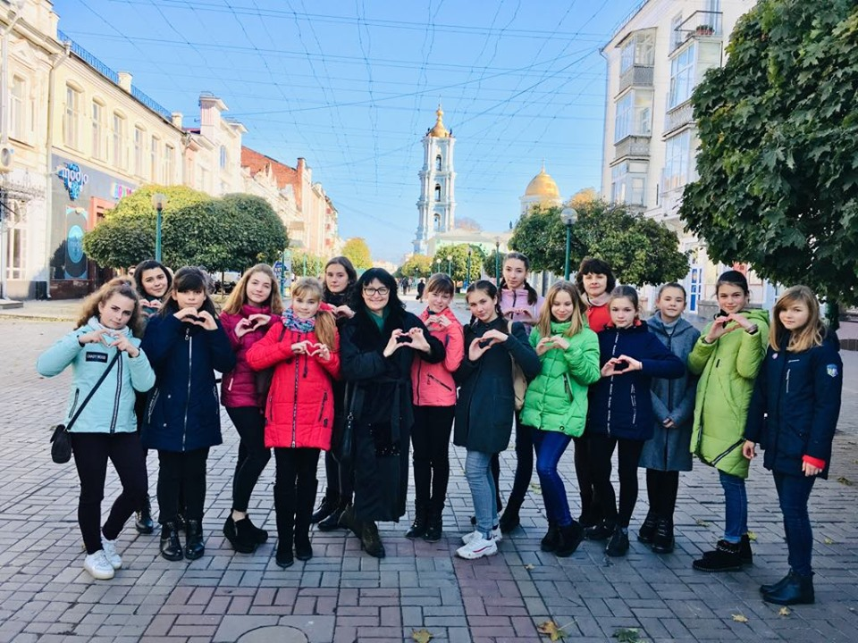

**WEEK 1 SOS4LoveProject3**

**04/10-13/10**

**Goal 14 Life below water**

**Project Theme “Let’s save our river!”**

**Secondary school №11 of Romny, Sumy region, Ukraine**

**2A form**

**Primary school teacher:** Viktoria Nikolaienko

**Personal qualities:** serious, self-development, caring

**Hobbies:** quilling, travelling, reading

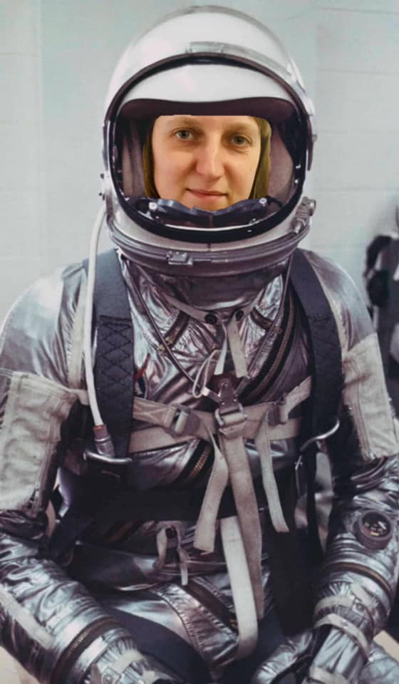

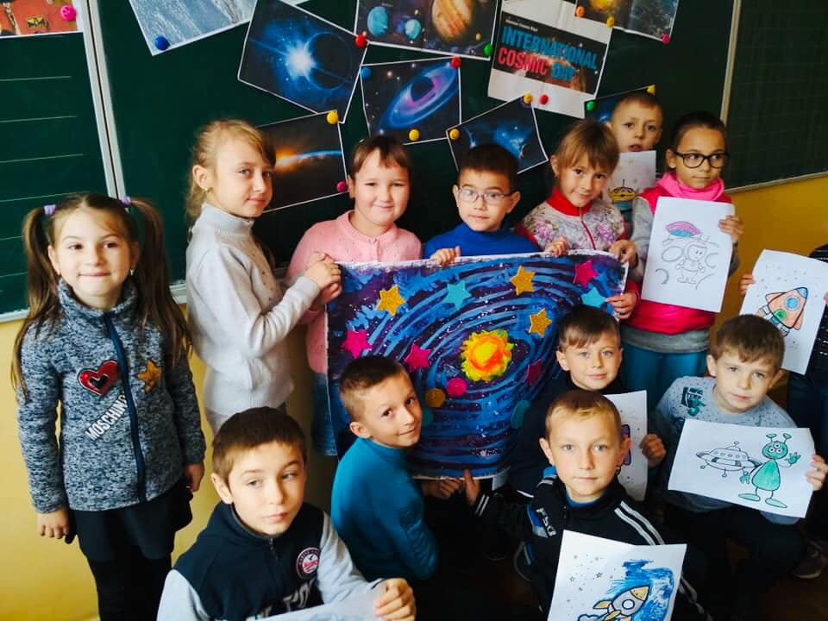

**WEEK 1 SOS4LoveProject3**

**Goal 3 Good health and well-being**

**Project Theme “A sound mind in a sound body”**

**04/10-13/10**

**Secondary school №11 of Romny, Sumy region, Ukraine**

**9A form**

**Geography teacher:** Liudmyla Melnyk

**Personal qualities:** easy-going, sociable, chatty

**Hobbies:** tourism, active leisure, gardening

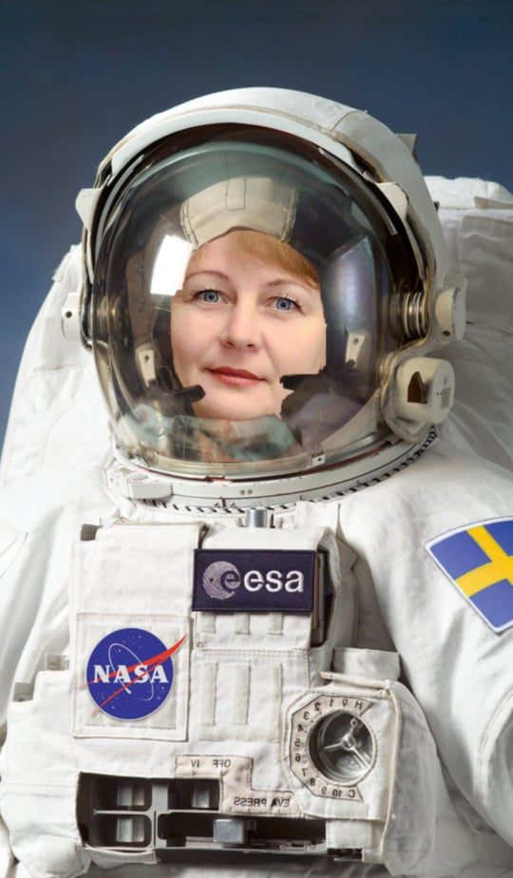

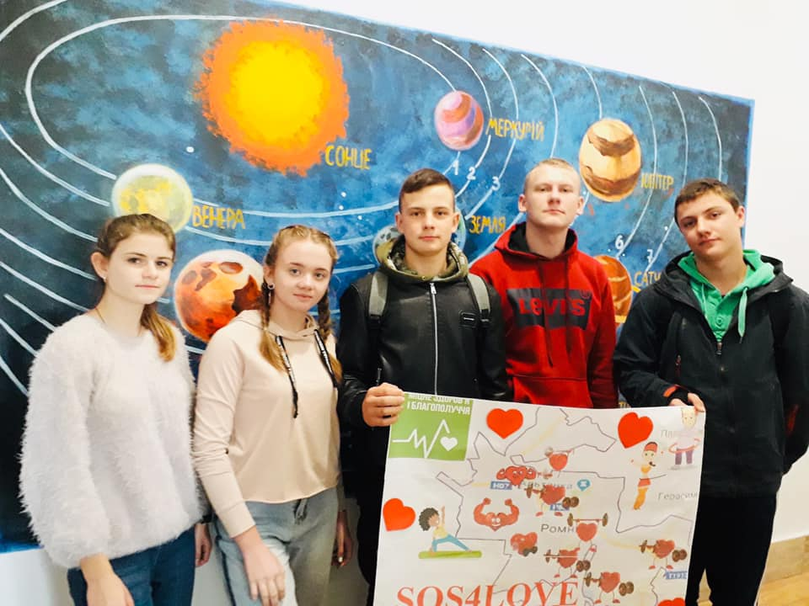

**WEEK 1 SOS4LoveProject3**

**Goal 5 Gender equality**

**Project theme: “Gender equality: does it exist in Ukraine and why do we need it?”**

**04/10-13/10**

**Secondary school №11 of Romny, Sumy region, Ukraine**

**6B form**

**History Teacher:** Oksana Vovdenko

**Personal qualities:** cheerful, friendly, sociable

**Hobbies:** travelling, reading

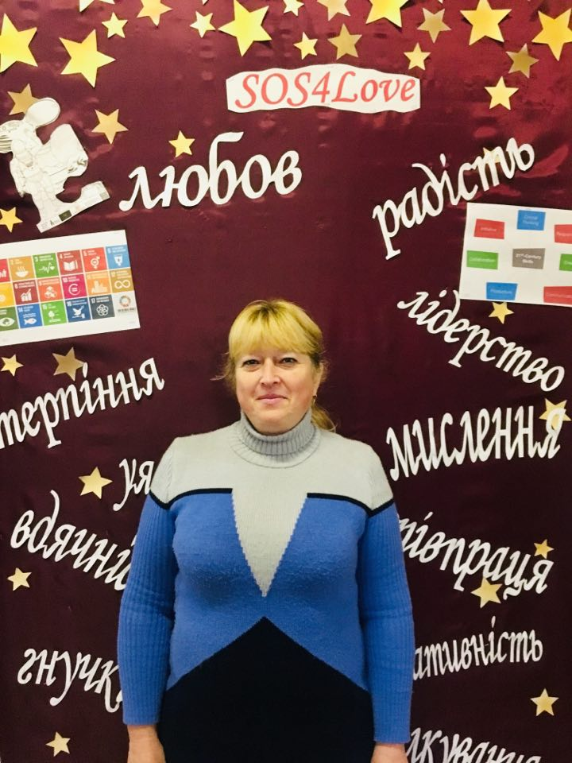

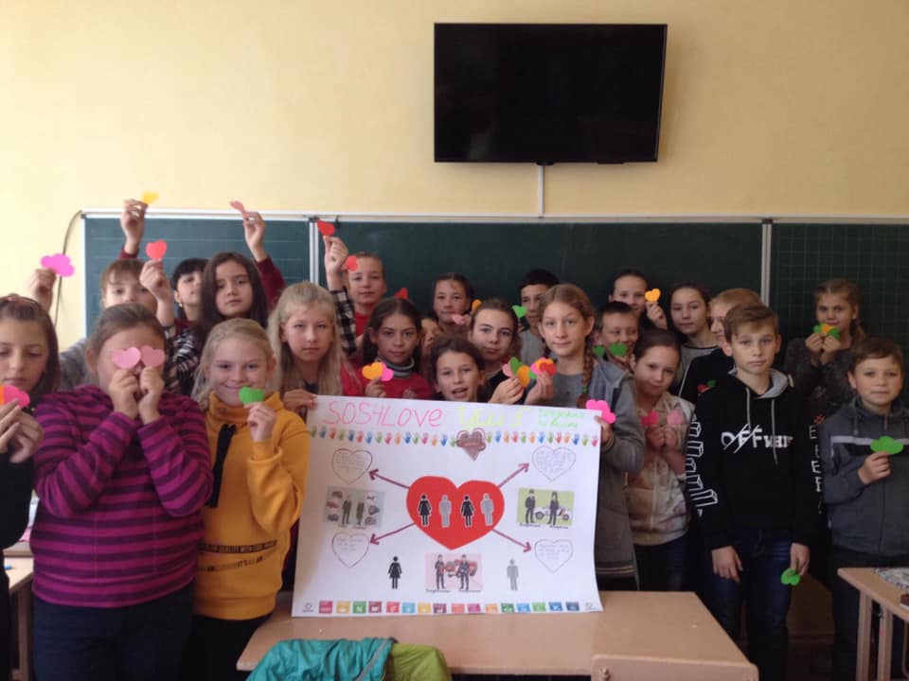

**WEEK 1 SOS4LoveProject3**

**Goal 15 Life on land**

**Project Theme “Help because of love”**

**04/10-13/10**

**Secondary school №11 of Romny, Sumy region, Ukraine**

**3C form**

**Primary school teacher:** Tetiana Orobchenko

**Personal qualities:** cheerful, creative, sociable

**Hobbies:** pet lover, reading

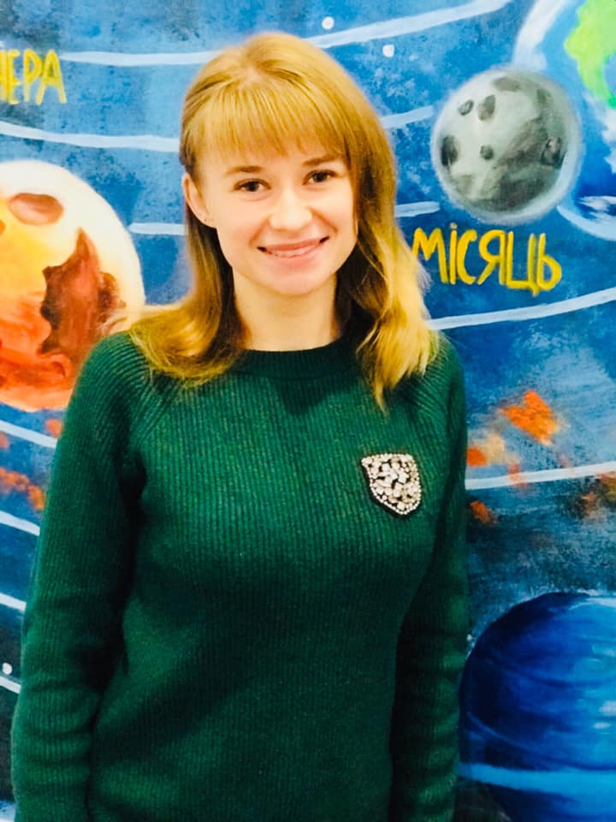

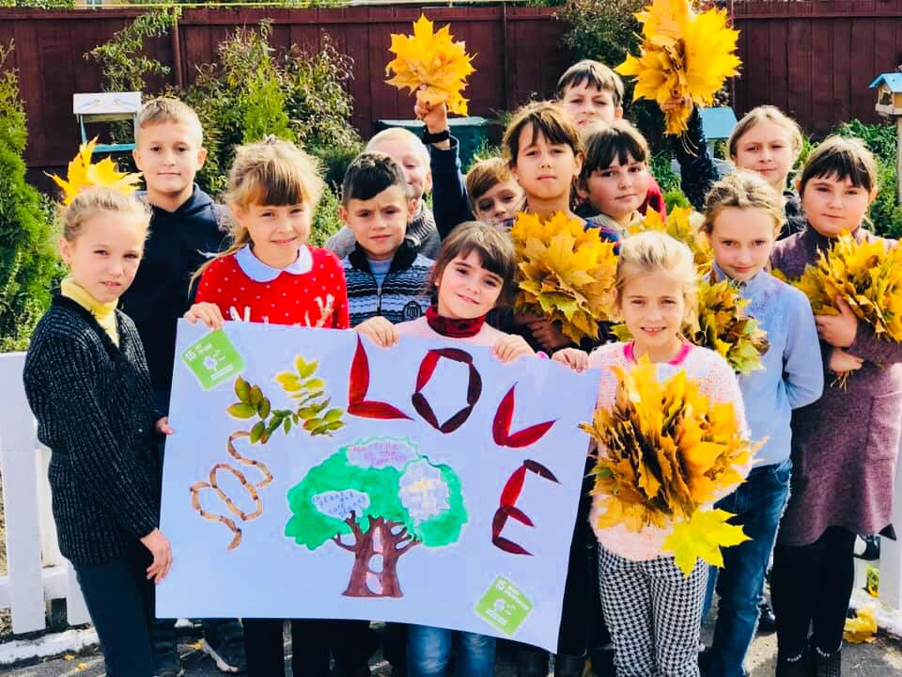

**WEEK 1 SOS4LoveProject3**

**Goal 12 Responsible consumption and production**

**Project Theme “Fallen leaves: is it good or harmful?”**

**04/10-13/10**

**Secondary school №11 of Romny, Sumy region, Ukraine**

**1C form**

**Primary school teacher:** Lesia Papiy

**Personal qualities:** cheerful, creative, sociable, reliable

**Hobbies:** handiwork, reading, tourism

