**School** : Escuela secundaria San Pedro de Colalao- Tucuman-Agentina

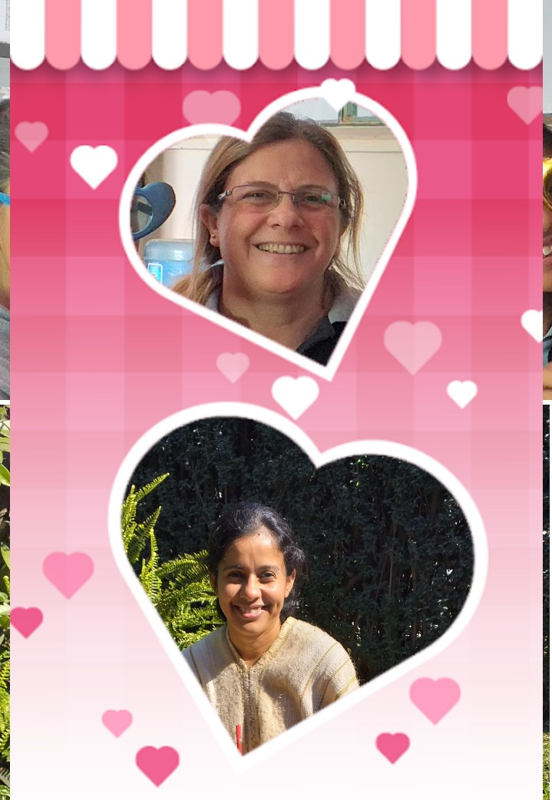 **Teachers facilitators :**

***Curubeto, Roxana***

Teacher of History ,8 years working in the school.

Strong commitment to equility and human rights

***Vaca, Laura Ines***

Teacher of English, 7 years working in the school.

Strong commitment to peace and cultural diversity.

This our Project: ***Education for Peace and Cultural diversity.***

Here we share some of the photos of our students reflexions.

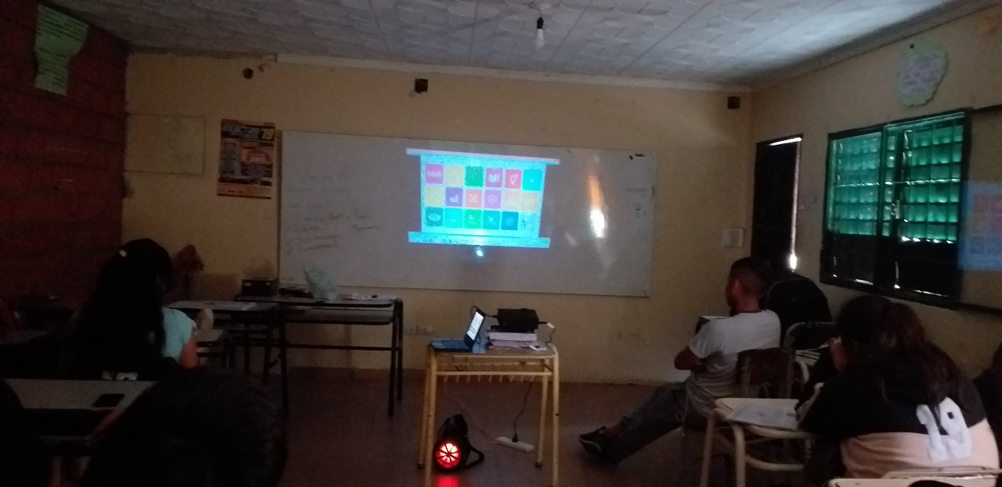

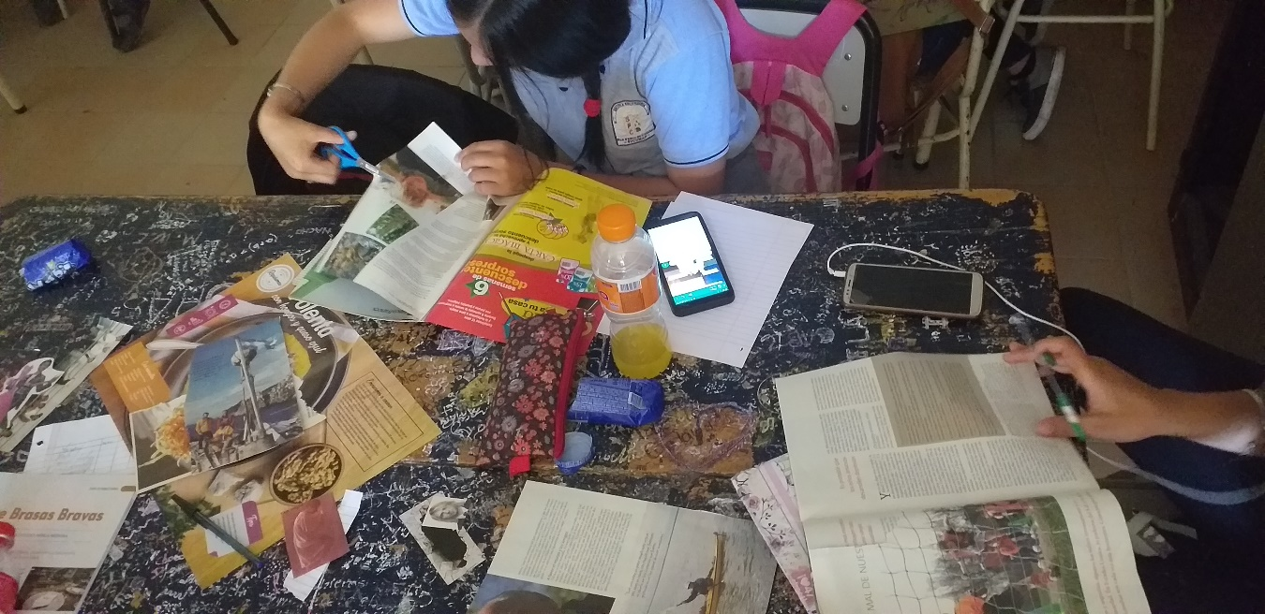

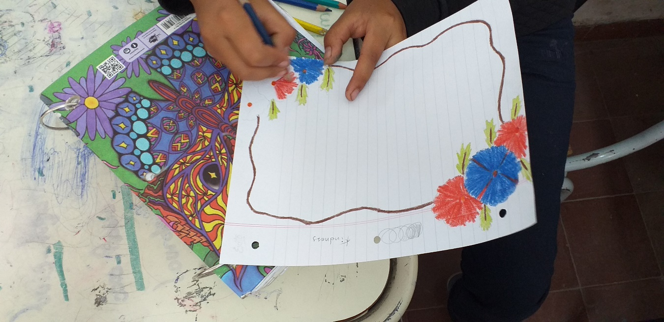

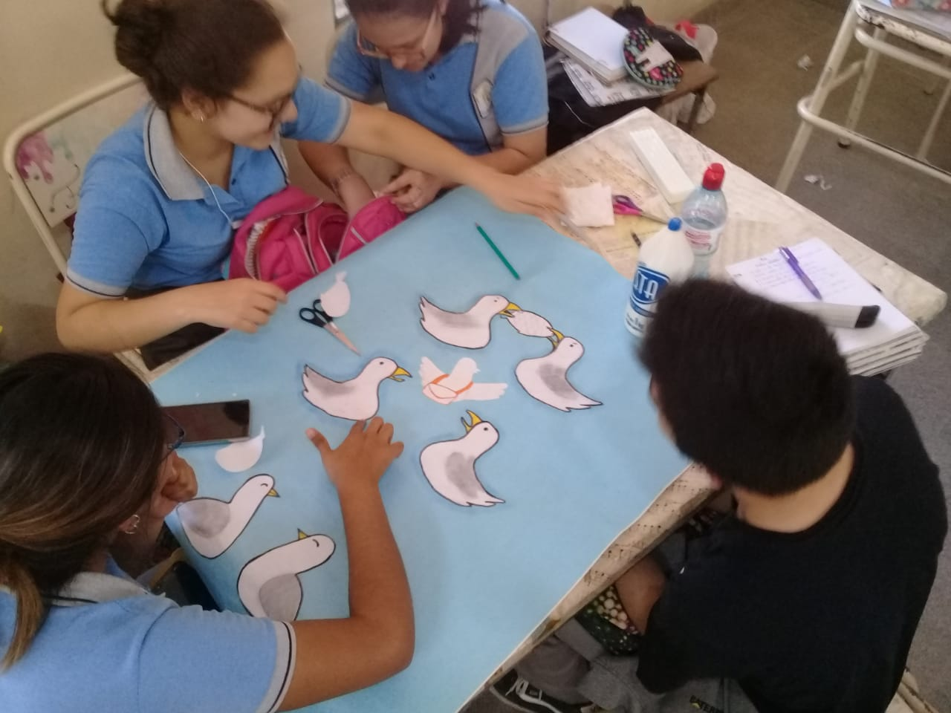

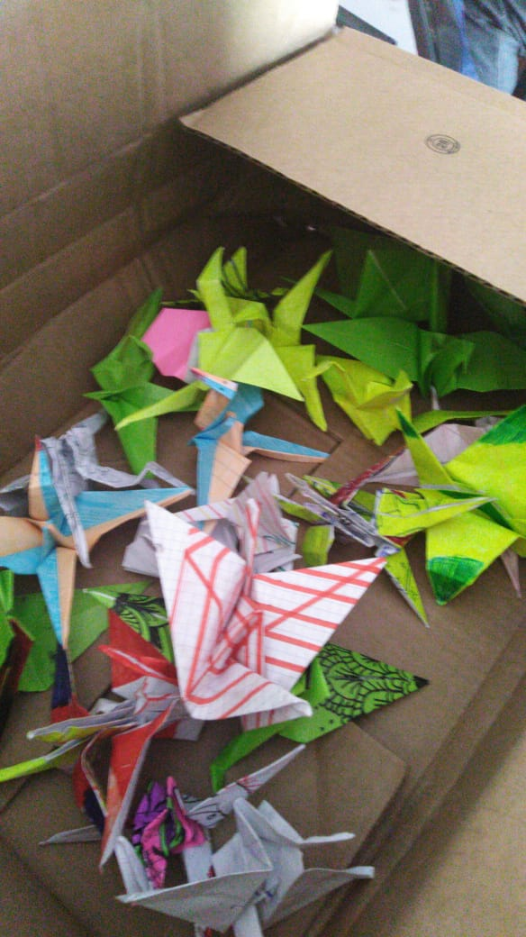

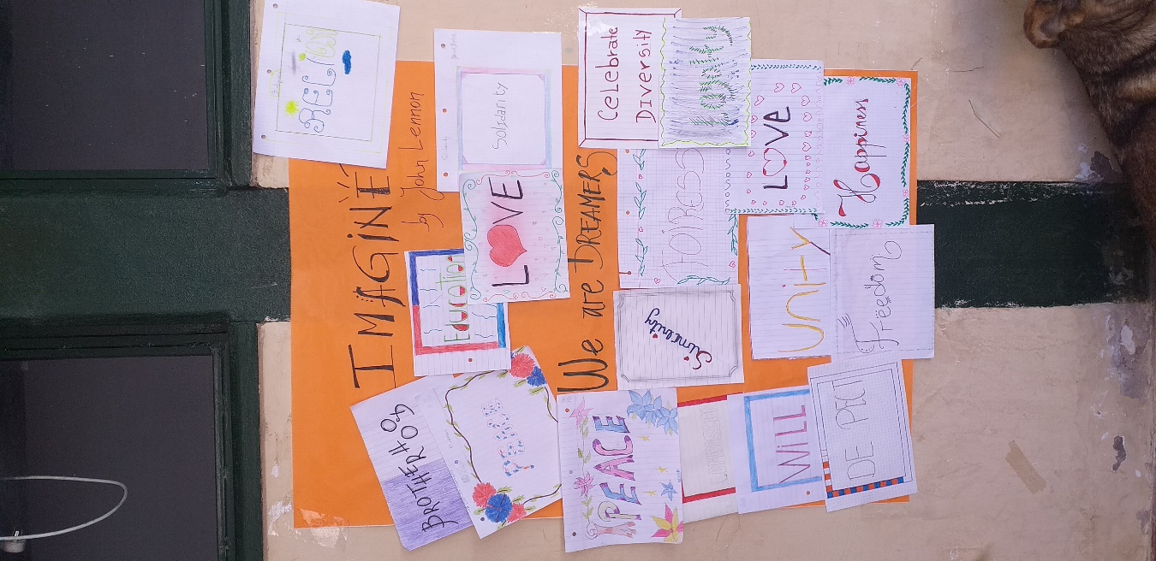 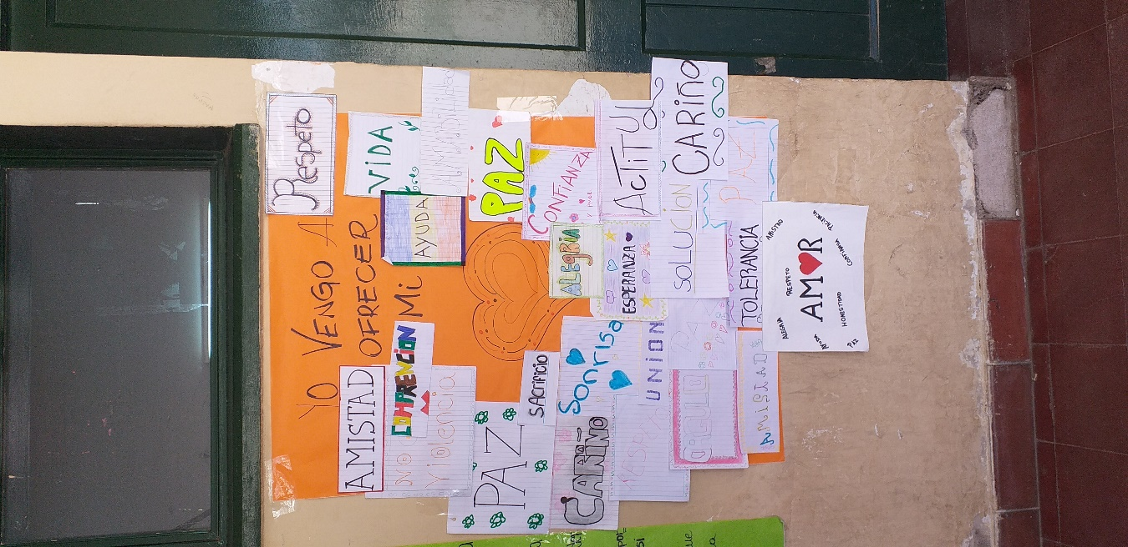

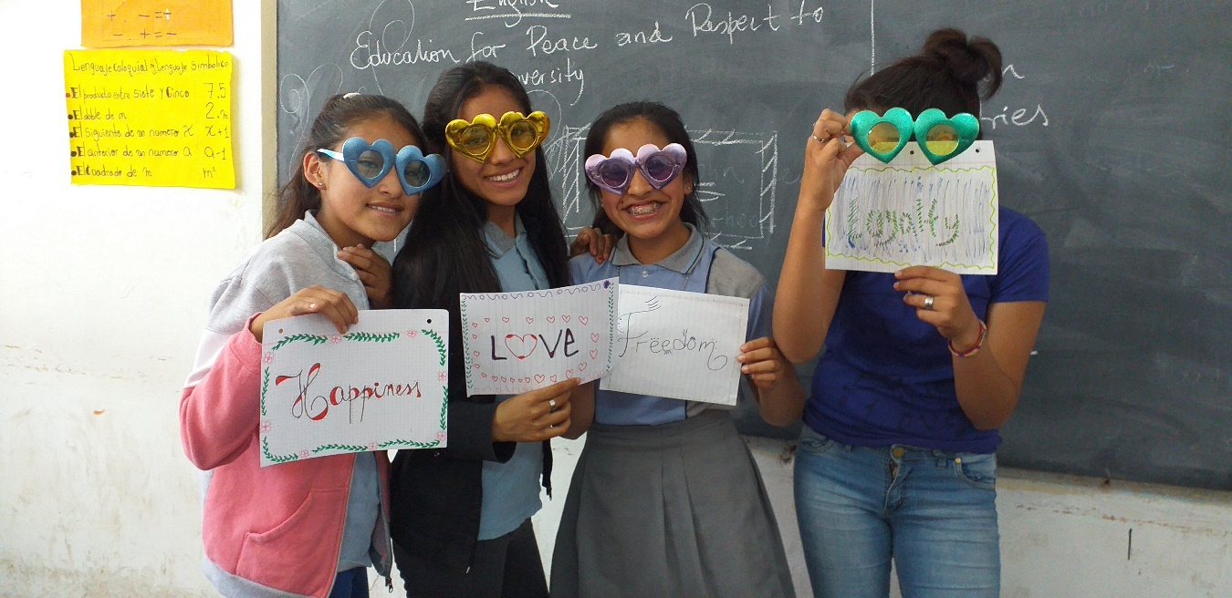

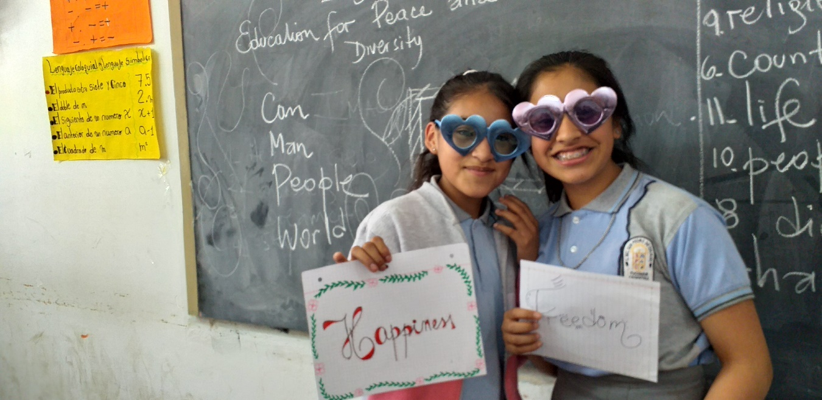

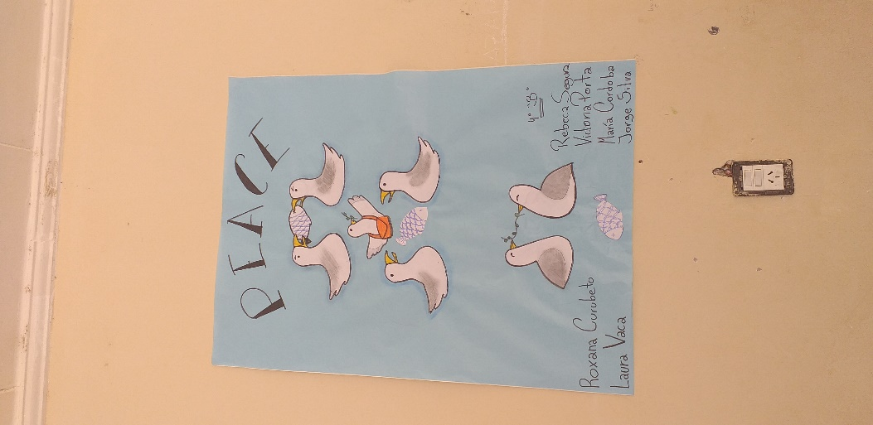 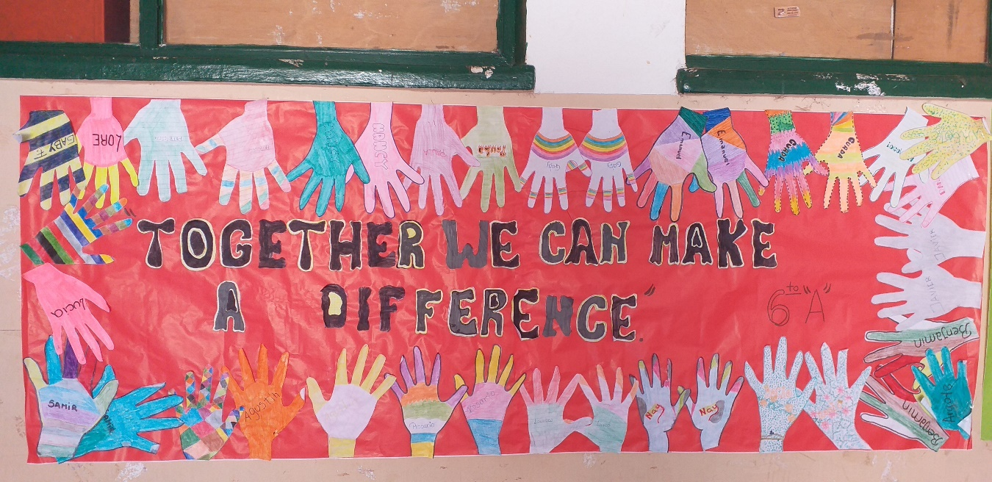

We believe in the power of LOVE to make our school a place for everyone.